# NX4024T032

## Contents

 [[hide](https://www.itead.cc/wiki/NX4024T032)]

* [1 Overview](https://www.itead.cc/wiki/NX4024T032#Overview)
* [2 Nextion Models](https://www.itead.cc/wiki/NX4024T032#Nextion_Models)
* [3 Specification](https://www.itead.cc/wiki/NX4024T032#Specification)
* [4 Electronic Characteristics](https://www.itead.cc/wiki/NX4024T032#Electronic_Characteristics)
* [5 Working Environment & Reliability Parameter](https://www.itead.cc/wiki/NX4024T032#Working_Environment_.26_Reliability_Parameter)
* [6 Interfaces Performance](https://www.itead.cc/wiki/NX4024T032#Interfaces_Performance)
* [7 Memory Features](https://www.itead.cc/wiki/NX4024T032#Memory_Features)
* [8 Product Dimension](https://www.itead.cc/wiki/NX4024T032#Product_Dimension)

## Overview

[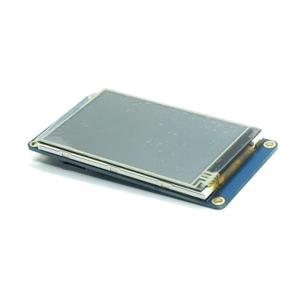](https://www.itead.cc/wiki/File:NX4024T032.jpg)

[IMG_257](https://www.itead.cc/wiki/File:NX4024T032.jpg)

Nextion is a Seamless Human Machine Interface (HMI) solution that provides a control and visualisation interface between a human and a process, machine, application or appliance. Nextion is mainly applied to IoT or consumer electronics field. It is the best solution to replace the traditional LCD and LED Nixie tube. With the software - Nextion Editor ([Official Download](http://nextion.itead.cc/download.html)), users are able to create and design their own interfaces for Nextion display.

Go shopping [NX4024T032 (im150416005)](http://imall.itead.cc/nextion-nx4024t032.html)

## Nextion Models

|  |  |
| --- | --- |
| Nextion Type | Basic |
| Nextion Models | NX4024T032\_011N (N: No touch) |
| NX4024T032\_011R (R: Resistive touchscreen) |

[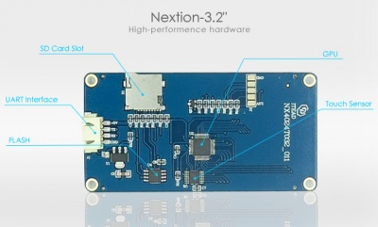](https://www.itead.cc/wiki/File:Nx32.jpg)

Package include: a Nextion 3.2" display, a wire, a power supply test board

**Note:** there's a small power supply test board and a wire for you to test if the electricity supply is enough or not. Please see below image how to use it.

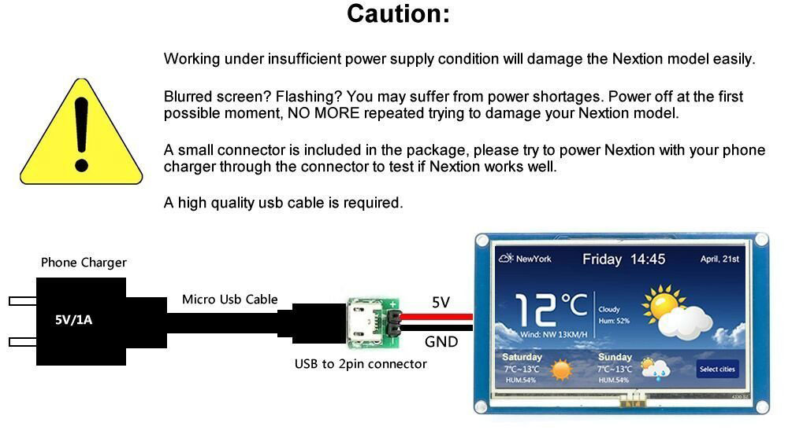

## Specification

|  |  |  |
| --- | --- | --- |
|  | **Data** | **Description** |
| Color | 65K (65536) colors | 16 bit, 5R6G5B |
| Layout size | 95(L)×47.6(W)×4.6(H) | NX4024T032\_011N |
| 95(L)×47.6(W)×5.8(H) | NX4024T032\_011R |
| Active Area (A.A.) | 80.90mm(L)×47.60mm(W) | - |
| Visual Area (V.A.) | 69.60mm(L)×41.76mm(W) | - |
| Resolution | 400×240 pixel | Also can be set as 240×400 |
| Touch type | Resistive | - |
| Touches | > 1 million | - |
| Backlight | LED | - |
| Backlight lifetime (Average) | >30,000 Hours | - |
| Brightness | 200nit (NX4024T032\_011N) | 0% to 100%, the interval of adjustment is 1% |
| 180 nit (NX4024T032\_011R) | 0% to 100%, the interval of adjustment is 1% |
| Weight | 35.5g (NX4024T032\_011N) | - |
| 42.5g (NX4024T032\_011R) | - |

## Electronic Characteristics

|  |  |  |  |  |  |
| --- | --- | --- | --- | --- | --- |
|  | **Test Conditions** | **Min** | **Typical** | **Max** | **Unit** |
| Operating Voltage |  | 4.75 | 5 | 7 | V |
| Operating Current | VCC=+5V, Brightness is 100% | - | 85 | - | mA |
| SLEEP Mode | - | 20 | - | mA |
| Power supply recommend：5V, 500mA, DC | | | | | |

## Working Environment & Reliability Parameter

|  |  |  |  |  |  |
| --- | --- | --- | --- | --- | --- |
|  | **Test Conditions** | **Min** | **Typical** | **Max** | **Unit** |
| Working Temperature | 5V, Humidity 60% | -20 | 25 | 70 | ℃ |
| Storage Temperature | - | -30 | 25 | 85 | ℃ |
| Working Humidity | 25℃ | 10% | 60% | 90% | RH |

## Interfaces Performance

|  |  |  |  |  |  |
| --- | --- | --- | --- | --- | --- |
|  | **Test Conditions** | **Min** | **Typical** | **Max** | **Unit** |
| Serial Port Baudrate | Standard | 2400 | 9600 | 115200 | bps |
| Output High Voltage | IOH=-1mA | 3.0 | 3.2 | - | V |
| Output low Voltage | IOL=1mA | - | 0.1 | 0.2 | V |
| Input High Voltage | - | 2.0 | 3.3 | 5.0 | V |
| Input low Voltage | - | -0.7 | 0.0 | 1.3 | V |
| Serial Port Mode | TTL | | | | |
| Serial Port | 4Pin\_2.54mm | | | | |
| USB interface | NO | | | | |
| SD card socket | Yes (FAT32 format), support maximum 32G Micro SD Card | | | | |

## Memory Features

|  |  |  |  |  |  |
| --- | --- | --- | --- | --- | --- |
| **Memory Type** | **Test Conditions** | **Min** | **Typical** | **Max** | **Unit** |
| FLASH Memory | Store fonts and images | - | - | 4 | MB |
| RAM Memory | Store variables | - | 3584 | - | BYTE |

## [Product](https://www.itead.cc/wiki/Product) Dimension

[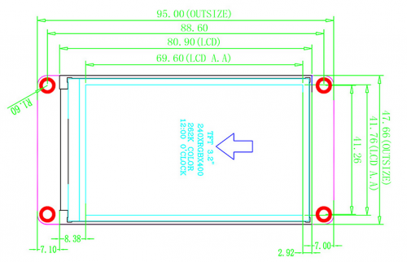](https://www.itead.cc/wiki/File:NX4024T032_(IM150416005).png)

85

78.6